IP, Subnetting & CIDR

# 

# Abstract

This research and development document outlines a detailed perspective of IP addressing and subnetting with the emphasis on the IPv4 and IPv6. It describes basic terminologies like address structures, subnet masks, CIDR notation and address classes. Using examples and calculations the document shows the way to make subnets, to compute usable and total hosts and to apply CIDR to IPv4 and IPv6 networks. It can be used as a technical manual on how to interpret and apply an efficient network division.

# Introduction

The IP addressing is the foundation of the current networking service where devices are able to discover and talk with one another in the local and worldwide networks. As IPv4 addresses become short and IPv6 introduced, knowledge of address format and address subnetting have become a key skill in network design and management.

In this document, the IPv4 and IPv6 addressing schemes are presented and their structural differences noted, as well as how subnetting helps to increase router efficiency and resource allocation. The classful (A, B, C) addressing and the classless addressing methods employing the CIDR notation is explained well. Examples of subnetting provide calculated explanations of address ranges, subnet masks, total host and number of available hosts. It also includes IPv6 addressing using CIDR which shows the next generation network is flexible and has very large capacity.

# IP addressing:

## IPv4 Addressing

* IPv4 has a 32- bit address which is divided into 4 octets.
* Represented by using dotted decimals (e.g. 192.168.1.1).
* Range of octet 0 to 255.
* The IP address classes ( A to E ) were initially used to subdivide IP addresses into fixed-size blocks with default subnet sizes where (A-C) classes are used for hosts, D for multicast and E is used for experimental purposes . CIDR (Classless Inter - Domain Routing) can also be used in IPv4 addressing

IPv6 Addressing

* IPv6 address is 128 bits long and is represented in hexadecimal format(e.g. 2001:0db8:85a3::8a2e:0370:7334).
* It is designed due to a shortage of IPv4 addresses.
* Much more addresses than IPv4 ( 3.4 * 10^38).
* Only CIDR (Classless Inter - Domain Routing) can be used in IPv6 addressing.

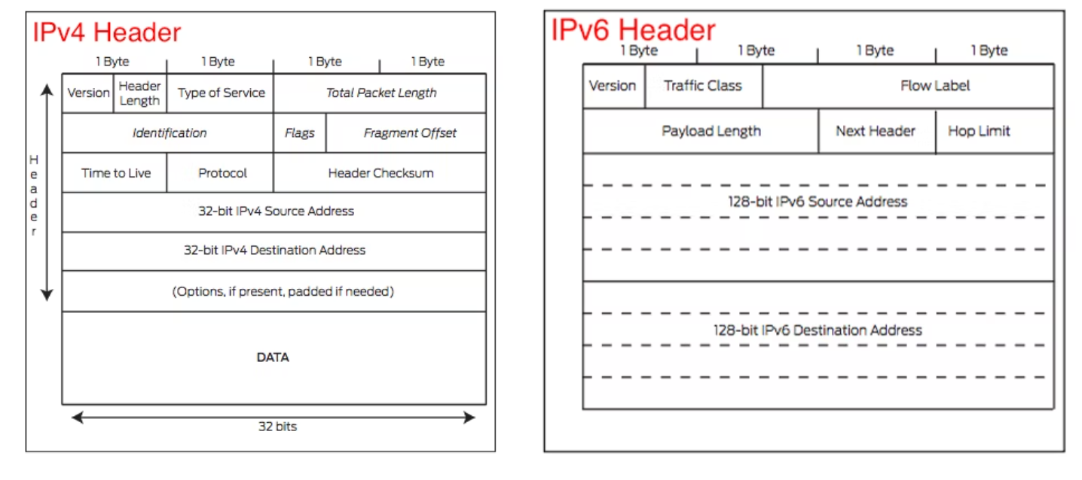

## Subnetting

Subnetting separates a network into logical smaller segments through the borrowed host bits for network identification. This enhances efficiency in routing, management as well as security.

**Key Terms:-**

* **Network Address:** It identifies the subnet as this is the first address of every subnet.
* **Broadcast Address:** It is the last address which is used to reach all hosts.
* **Total hosts:** The IP address in total that is available on a subnet.
* **Usable Hosts:** It subtracts the (network and broadcast address) from the total host.
* **Subnet Mask:** It helps to identify the host and network bits.
* **CIDR:** e.g., /24.

## IPv4 classes and their Natural mask

| Class | Start | End | Default mask | CIDR |
| --- | --- | --- | --- | --- |
| A | 1.0.0.0 | 126.255.255.255 | 255.0.0.0 | /8 |
| B | 128.0.0.0 | 191.255.255.255 | 255.255.0.0 | /16 |
| C | 192.0.0.0 | 223.255.255.255 | 255.255.255.0 | /24 |

Class D is used for multicasting and E is used for Experimental purposes and both are reserved classes.

## Subnetting with Natural Mask and CIDR

Let's take example for IPv4 Subnetting:

For class C network:

Network:192.168.1.0

Default mask = 255.255.255.0

New subnet mask = 255.255.255.192

New CIDR = /26

* Conversion of decimal to binary:

11111111.11111111.11111111.11000000

255 . 255 . 255 . 192

| **Calculation** | **Result** |
| --- | --- |
| Total bits in IP | 32 |
| Network bits in /26 | 26 |
| Host bits | 32-26=6 |
| Total Address per subnet | 2^6=64 |
| Usable hosts per subnet | 2^6-2=62 |
| Number of subnets | 2^(26-24)=4 |

Subnets:

| Subnet | Range | Network address | Broadcast address |
| --- | --- | --- | --- |
| 1 | 192.168.1.0 - 192.168.1.63 | 192.168.1.0 | 192.168.1.63 |
| 2 | 192.168.1.64 - 192.168.1.127 | 192.168.1.64 | 192.168.1.127 |
| 3 | 192.168.1.128 - 192.168.1.191 | 192.168.1.128 | 192.168.1.191 |
| 4 | 192.168.1.192 - 192.168.1.255 | 192.168.1.192 | 192.168.1.255 |

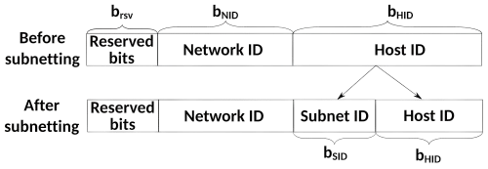

CIDR:

CIDR(Classless Inter-Domain Routing) allows for flexible subnetting by the help of prefix notation like /24, /25 etc., which further tells us how many bits are used for network and host address of IP. It helps to reduce the wastage of IP addresses.

CIDR to Subnet mask conversion:

| **CIDR** | **Subnet mask** | **Host bits** | **Total**  **hosts** | **Usable hosts** | **Explanation** |
| --- | --- | --- | --- | --- | --- |
| /24 | 255.255.255.0 | 8 | 256 | 254 | 32-24=2^8-2 |
| /25 | 255.255.255.128 | 7 | 128 | 126 | 32-25=2^7-2 |
| /26 | 255.255.255.192 | 6 | 64 | 62 | 32-26=2^6-2 |
| /27 | 255.255.255.224 | 5 | 32 | 30 | 32-27=2^5-2 |
| /28 | 255.255.255.240 | 4 | 16 | 14 | 32-28=2^4-2 |
| /29 | 255.255.255.248 | 3 | 8 | 6 | 32-29=2^3-2 |
| /30 | 255.255.255.252 | 2 | 4 | 2 | 32-30=2^2-2 |

CIDR and subnetting in IPv6:

* The IPv6 address is 128 bit long.
* The format of IPv6 address could be represented as 8 groups of 4 hexadecimal digits(e.g.,2001:0db8:abcd:0012::1).
* Consecutive zeros could be reduced by the help of double colon(::).
* IPv6 standard size is /64
* It means 64 bits got reserved for network prefix, and the remaining bits are left for the host ID.

Allocation:

| CIDR | Use case |
| --- | --- |
| /48 | Given to big organizations |
| /56 | Given to small businesses |
| /64 | Only given to single LAN |

Example:

* Imagine that you have been given the following IPv 6 prefix:
* Prefix: 2001:0db8:abcd::/48.
* You have the /48 subnet allocation in which the initial 48 bits are fixed.
* In order to form /64 subnets, additional 16 bits are required (64 - 48 = 16).
* That way you can devise 2^16 = 65,536 distinctive /64 subnets.

| **Subnet No** | **IPv6 /64** |
| --- | --- |
| 1 | 2001:0db8:abcd:0000:: /64 |
| 2 | 2001:0db8:abcd:0001:: /64 |
| 3 | 2001:0db8:abcd:0002:: /64 |
| till… | till... |
| 65536th | 2001:0db8:abcd:ffff:: /64 |

The computations

**Formula for IPv4:**

Total hosts = 2^n

Usable Hosts = 2^n - 2

n = number of host bits

(we take away 2 address of network & broadcast)

**Formula for IPv6:**

Total hosts =2^n.

Usable Hosts=2^n.

n = number of host bits

In /64 ( = 2^64 hosts ).

The broadcast address is not there under IPv6.

# Conclusion

Subnetting and IP addressing form the basics of network design. This document discussed IPv4 and IPv6 hierarchy, subnet mask, CIDR, and the calculation of the number of total and available hosts. As IPv4 is beginning to become exhausted, IPv6 is scalable. The knowledge of these concepts implies effective and safe network management.